ANL Policies & Procedures 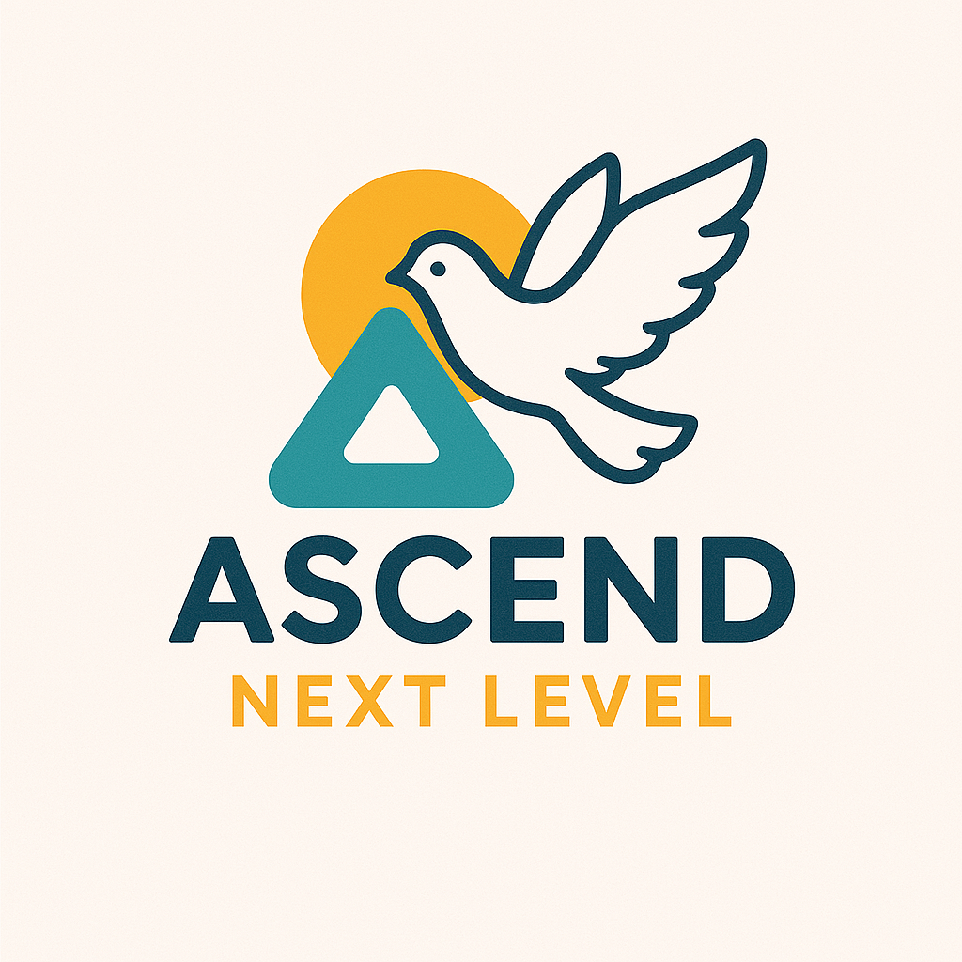

| Name | **ANL Safeguarding Policy** |
| --- | --- |
| Version | 1 |
| Date approved by Directors | 02.06.25 |
| Date implemented |  |
| Date of next review | 01.06.26 |
| Author | Cheryl Cross and Pam Grimshaw |

| Target Audience | This policy applies to all staff and volunteers of ANL |
| --- | --- |
| Summary | This policy sets out our clear intention to keep all people involved in ANL activities in any way, safe. |
| Changes since last version |  |

| **Name** | **Title** | **Signature** |
| --- | --- | --- |
| Cheryl Cross | DSL, |  |

**ANL Safeguarding Policy**

**1. Introduction**  
This Safeguarding Policy outlines our commitment to ensuring the safety, well-being, and protection of young people and adults at risk of harm in all our activities and services. We recognise our duty to prevent harm, abuse, and exploitation and to provide a safe environment for all individuals engaging with our organisation, especially because, as Christians, we believe that every person is made in the image of God and we seek to show God’s love and care as an organisation. This policy aligns with UK safeguarding legislation and best practices.

Ascend Next Level CIC encourages and supports young people and their families to live life well. We long to see people flourish as they engage in the positive experiences we offer in terms of outdoor adventure, different forms of creative expression (art,dance, music, building projects etc) and Christian prayer. The directors are responsible for leading our Safeguarding arrangements: governance and accountability is in place.

**2. Purpose and Scope**  
The purpose of this policy statement is:

• to protect children, young people and adults at risk of abuse who receive Ascend Next Level’s services from harm. This includes the children of adults who use our services

• to provide staff and volunteers, as well as children and young people and their families, with the overarching principles that guide our approach to safeguarding because we recognise the need to provide a safe and caring environment for children, young people, and adults.

This policy applies to all paid staff, volunteers, contractors, directors and anyone working on behalf of Ascend Next Level. It covers all activities involving young people and adults at risk of abuse, whether in-person or online.

**3. Supporting Documents**

This policy statement should be read alongside our organisational policies, procedures, guidance and other related documents as listed below:

* Role description for the Designated Safeguarding Lead
* Dealing with Disclosures and Concerns about a Child or Young Person
* Definitions of Abuse Supporting document
* Equality, Diversity and Inclusion Policy
* Managing Allegations Against Staff and Volunteers
* Recording Concerns and Information Sharing
* Child Protection Records Retention and Storage
* Code of Conduct for Staff and Volunteers
* Behaviour Codes for Children and Young People
* Photography and sharing images guidance
* Safer Recruitment
* Online Safety
* Anti-Bullying
* Managing Complaints
* Speaking Up
* Health and Safety
* Induction, Training, Supervision and Support
* Adult to Child Supervision Ratios.

**4. Legal Framework**

This policy has been drawn up on the basis of legislation, policy and guidance that seeks to protect children in the United Kingdom.

**5. Definitions**

**Safeguarding** is protecting a person’s health and human rights enabling them to live free from harm, abuse and neglect and promoting their wellbeing.

**A child or young person** is anyone under the age of 18.

**A young adult** is anyone between the age of 18 and 25 years.

**An Adult at Risk of Abuse is an adult who:**

* Is experiencing, or is at risk of, abuse or neglect;
* As a result of those needs cannot protect themselves against the abuse or neglect of which they are at risk.

**An Adult with Care and Support Needs is an adult who:**

* requires help with a mixture of practical, emotional and financial tasks to manage their lives and be independent.

**An Adult with Identifiable Vulnerabilities** is any adult who doesn’t reach the threshold to be an ‘adult with care and support needs’ but who does have other recognisable needs eg managing finances.

**A Vulnerable Adult is anyone who falls into any of the above three categories.**

**Safeguarding children and young people includes:**

* Protecting them from maltreatment or things that are bad for their health or development.
* Making sure they grow up in circumstances that allow safe and effective care.
* Taking action to enable all children and young people to have the best outcomes.

**Safeguarding adults includes:**

* Protecting their rights to live in safety, free from abuse and neglect.
* People and organisations working together to prevent the risk of abuse or neglect, and to stop them from happening.
* Making sure people's wellbeing is promoted, taking their views, wishes, feelings and beliefs into account.

(Definition taken from Care Quality Commission November 2022)

**In legislative guidance, we recognise there are four main types of abuse of children** ie physical, sexual, emotional and neglect; **and ten main types of abuse for vulnerable adults:** physical, domestic violence, sexual, psychological / emotional, financial, modern slavery, discriminatory, institutional, neglect and self-neglect. **These are defined in our separate ‘Definitions of Abuse’ document.**

**6. Statement of Commitment**

**Ascend Next Level** is committed to safeguarding and promoting the welfare of all children and adults at risk of harm in our care. We believe that safeguarding is everyone's responsibility and that the welfare of the children and adults at risk of harm in our care is paramount. ANL values everyone as an individual and treats all equally and fairly. ANL has a statutory and moral duty to commit to practices that protect children and adults at risk from harm, from abuse. This policy outlines our commitment to safeguarding and the measures we take to protect those in our care.

We recognise that:

* the welfare of children and vulnerable adults is paramount in all the work we do and in all the decisions we take;
* working in partnership with children, their parents, carers and other agencies is essential in promoting young people’s welfare;
* everyone, regardless of age, disability, gender reassignment, race, religion or belief, sex, or sexual orientation have an equal right to protection from harm and abuse;
* we recognise that vulnerable people may require additional support because of the impact of previous experiences, their level of dependency, communication needs or other issues and that extra safeguards may be needed to keep people who are additionally vulnerable safe from abuse.

**We will seek to keep everyone safe by:**

* valuing, listening to and respecting them;
* appointing a Designated Safeguarding Lead and Deputy Designated Safeguarding Lead who are appropriately trained and knowledgeable;
* making sure all staff and volunteers understand and follow the safeguarding policy and supporting documents;
* ensuring everyone knows about the organisation's safeguarding policies and what to do if they have a concern ie policies and practices are available and accessible to all;
* building a safeguarding culture where staff, volunteers and children know how they are expected to behave and feel comfortable about sharing concerns;
* providing effective management for staff and volunteers through supervision, support, training and quality assurance measures so that all staff and volunteers know about and follow our policies, procedures and behaviour codes confidently and competently;
* uphold our Safer Recruitment policy to ensure any that any staff member or volunteer who joins our team is suitable for the role they hold and where appropriate, has a valid, up to date DBS check appropriate to the level of contact they will have with children, young people and vulnerable adults;
* recording and storing and using information professionally and securely, in line with our GDPR policy;
* sharing information about safeguarding and good practice with children and their families via leaflets, posters, group work and one-to-one discussions;
* using our safeguarding procedures to share concerns and relevant information with agencies who need to know, and involving children, young people, parents, families and carers appropriately;
* using our procedures to manage any allegations against staff and volunteers appropriately and respond compassionately to the victims of such abuse past or present;
* creating and maintaining an anti-bullying environment as per our anti-bullying policy;
* ensuring that we have effective complaints and speaking up measures in place;
* ensuring that we provide a safe physical environment for our children, young people, staff and volunteers, by applying health and safety measures in accordance with the law and regulatory guidance.

**7. Monitoring and Review**

* The Safeguarding arrangements will be reviewed at least annually for effectiveness and to ensure compliance with regulatory changes and best practices, initially by the Safeguarding DSL and Deputy, but ultimate responsibility lies with the directors.

**8. Christian Practice, Theology and Pastoral Care**

* Ascend Next Level is a Christian organisation and all staff and volunteers profess Christian faith. However, young people of all faiths and no faith are welcome to engage with all projects and programmes we deliver and will be treated equitably regardless of faith. Staff and volunteers are expected to be aware of and respectful of this fact, particularly when any conversations about faith take place. At no point should staff or volunteers apply any pressure to an individual to adopt Christian beliefs or engage in associated practices.
* Staff and volunteers working on behalf of Ascend Next Level may hold a range of theological beliefs on different topics. It may be appropriate for staff and volunteers to share their views if young people or vulnerable adults ask them to do so; however, to safeguard young people and vulnerable adults, staff and volunteers may not share condemning views on contentious theological topics. These include, but are not restricted to, gender identity and expression, sexuality, and abortion.
* Safeguarding a young person’s or vulnerable adult’s mental health and wellbeing is of the highest importance, and any conversations around faith and theology should take place with this perspective.
* If at any point a staff member or volunteer feels ill-equipped to engage in faith conversations in the way that is outlined in this document, they should ask a director for further support and training and should encourage young people or vulnerable adults with any questions to speak to another team member or volunteer instead.
* Where partners are working with Ascend Next Level staff or volunteers to deliver faith-based programmes, they are also expected to follow the guidelines outlined in this document.

**9. Contact Information**

* **Designated Safeguarding Lead (DSL):** Cheryl Cross, 07749869360, [cheryljcross@gmail.com](mailto:cheryljcross@gmail.com)
* **Deputy Safeguarding Lead:** Stephen Dolley, 07980446573, [sjdolley@gmail.com](mailto:sjdolley@gmail.com)
* **Local Authority Safeguarding Board: Derby and Derbyshire**  [ddscp@derby.gov.uk](mailto:ddscp@derby.gov.uk) <https://www.ddscp.org.uk/>
* **Children Social Care** 01629 533190
* **Adult Social Care email** [contact.centre@derbyshire.gov.uk](mailto:contact.centre@derbyshire.gov.uk). or ring 01629 533190
* **Christian Safeguarding Services** 0116 218 4420
* **NSPCC Helpline:** 0808 800 5000
* **Derby and Derbyshire Safeguarding Child Partnership Board** 01332 642351